Email #1: Introduction

Subject line options: | [Name], some key details about your refinance  Next steps for your refinance
Body: | Hi [Name],  Thanks for choosing [lender] for your new loan. The refinance process has begun!  Rather than a traditional refinance process, we’ll be using the FASTRefi® solution to activate your new loan. This means you’ll get access to your new loan terms and funds much sooner than in a traditional refinance process. And the good news is that there are no extra FASTRefi fees for you!  Your refinance process will look like this:  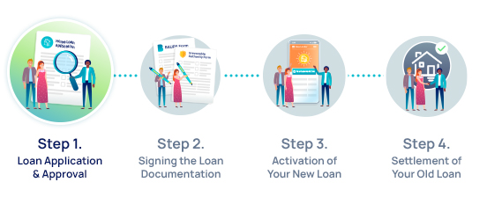  Step 1. Your loan application has been submitted and is being assessed by the credit team. We’ll also assess your loan for eligibility for the FASTRefi process which most loans qualify for.  What you need to do: Nothing! Your work for this step is done.  You may have noticed your loan application is for more than your current loan balance – don’t stress! To fully payout your current loan, we also need to cover any accrued interest, plus any fees charged by your old lender to close your account. To speed up the process, we make an estimate of the amount to fully payout your current loan which includes a small buffer to cover any unexpected amounts. Any surplus funds are paid to your nominated account when the settlement of your old loan is completed, which occurs in Step 4.  For now there is nothing more for you to do. We’ll be in touch again soon with tips for Step 2 in the process once your loan is approved.  If you have any questions in the meantime, please get in touch or click here to read more about FASTRefi, or view the attached guide.  [Lender signature/logo]
T&Cs: | Terms and conditions:  Loan suitability for the FASTRefi® product is determined by the lender in conjunction with the insurance product guidelines.  FASTRefi® is provided by First American Title Insurance Company of Australia Pty Limited ABN 64 075 279 908 Australian Financial Services Licence 263876, trading as First Title, an Australian general insurance company authorised by the Australian Prudential Regulation Authority.

Email #2: Documents Sent

Subject line options: | [Name], your important FASTRefi documents  To complete: Your refinance forms from FASTRefi
Body: | Hi [Name],  Congratulations on your refinancing approval! Now, let’s get on with Step 2 of the FASTRefi process…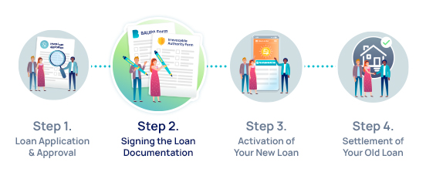  When you receive your new loan documents you will find two FASTRefi forms to be completed:  - The Borrower’s Acknowledgment, Undertaking and Payout Advice form (BAUPA)  - The Irrevocable Authority form  It’s important that these two forms are returned promptly and accurately, as we can’t begin the FASTRefi process without them. There are instructions on the forms to help you complete them, and feel free to reach out if you need any further assistance. If you need some extra guidance, we’ve created sample forms which you can find attached.  Important Actions you need to take now:  - Disclose ALL loans linked to the mortgage securing your current loan. This includes business loans, investment loans and guarantees.  - Ensure you cancel all direct debits linked to your old loan.  - Do not redraw any funds from the old loan account (this includes if your refinance is a line of credit).  - Continue making your standard loan repayments.  - Do not send the Discharge Authority to your existing lender. Sign and return it with the loan documents – we’ll handle this step for you.  Once you’ve submitted the BAUPA and Irrevocable Authority forms, along with your other loan documents, you’ll hear from us if we need any updates for the figures supplied. Otherwise, you can simply relax! Your new loan should be ready to go within in a matter of days.  If you have any questions, please get in touch.  [Lender signature/logo]
T&Cs: | Terms and conditions:  Loan suitability for the FASTRefi® product is determined by the lender in conjunction with the insurance product guidelines.  FASTRefi® is provided by First American Title Insurance Company of Australia Pty Limited ABN 64 075 279 908 Australian Financial Services Licence 263876, trading as First Title, an Australian general insurance company authorised by the Australian Prudential Regulation Authority.

Email #3: New Loan Confirmation

Subject line options: | [Name], your new loan is ready to go!  You can now access your new loan account
Body: | Hi [Name],  We’re happy to let you know your new loan is now accessible!  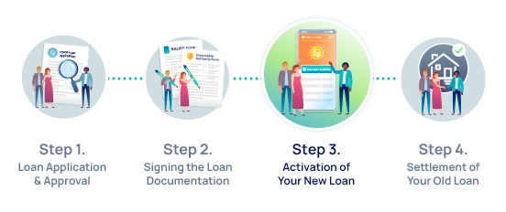  If you haven’t already, you’ll soon receive separate details on how to access your new account and make repayments.  You’re all set to start enjoying your new rate and any other features of your new loan.  You might still be able to see your old loan in your online banking – this is totally normal and nothing to worry about. If you notice interest accumulating on both your old and new loan accounts, remember that the interest charges on your old loan will be backdated to when the settlement payment was made to it.  You must not transact or redraw from this old loan account.  We’ll be in contact when this account is closed at settlement in Step 4.  If you have any questions, please get in touch.  [Lender signature/logo]
T&Cs: | Terms and conditions:  Loan suitability for the FASTRefi® product is determined by the lender in conjunction with the insurance product guidelines.  FASTRefi® is provided by First American Title Insurance Company of Australia Pty Limited ABN 64 075 279 908 Australian Financial Services Licence 263876, trading as First Title, an Australian general insurance company authorised by the Australian Prudential Regulation Authority.

Email #4: Settlement Confirmation

Subject line options: | [Name], settlement is now complete  Successful settlement for your loan refinance
Body: | Hi [Name],  Out with the old, and in with the new!  The settlement process is now complete and your old loan account is fully paid out.  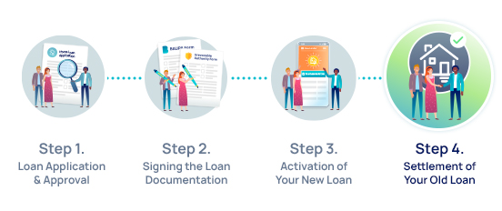  Any surplus funds that were not used to pay out your old loan will be returned to your nominated account automatically. Your old lender will send you a final statement once the account is closed. The statement will show the balance paid out, plus any interest or fees charged.  We hope you’ve had a smooth and easy experience with FASTRefi, and we’d like to thank you for selecting us as your lender of choice.  If you have any questions, please get in touch.  [Lender signature/logo]
T&Cs: | Terms and conditions:  Loan suitability for the FASTRefi® product is determined by the lender in conjunction with the insurance product guidelines.  FASTRefi® is provided by First American Title Insurance Company of Australia Pty Limited ABN 64 075 279 908 Australian Financial Services Licence 263876, trading as First Title, an Australian general insurance company authorised by the Australian Prudential Regulation Authority.

